INTERNATIONL JOURNAL OF COMPUTATIONAL SCIENCE AND TECHNOLOGY
First Author^{1, *}, Second Author² and Third Author³
¹Dept. of Electrical and Electronic Engineering, University, City, Country.
²Dept. of Electrical and Electronic Engineering, University, City, Country.
³Dept. of Electrical and Electronic Engineering, University, City, Country.
*Corresponding e-mail: @mailserver.com

Abstract – This article gives the overall view of the articles published in International Journal of Data Science and Artificial Intelligence. Abstract should be written in a motivate manner such a way it should make the readers to browse through the article completely. Abstract must be written with Times New Roman font with font size 9. Authors can make use of this template in preparing their final version of the manuscripts.
Keywords – List of Keywords that are used in the article should be written. All the keywords should be separated with commas. Minimum of four keywords must be written.
- INTRODUCTION
This section should introduce the article. Authors should introduce the problem that is going to be discussed in the entire article. Introduction section should motivate the readers to read the article further.
- Times New Roman font with size 10 should be used.
- Authors can make use of this template for preparing final version.
- Authors can make use of this template for preparing final version.
International Journal of Data Science and Artificial Intelligence is timely committed journal [1]. It accepts only unpublished manuscripts from the authors. KITS PRESS publishes research articles, survey papers and review articles. All the submitted manuscripts will be admitted in the review process of KITS PRESS. KITS PRESS follows single blind review process [1, 2]. That is the reviewers will know who the authors are and the authors do not know who the reviewers are. Submitted manuscripts will be sent to minimum of two reviewers. Decision will be made based on the reviews received. As soon as decision is made authors will be notified regarding the decision. Once the paper is accepted authors should transfer the copyright from to the KITS PRESS journal.
- RELATED WORK
All the related works that have been done by other researchers that are related to the current research problem should be summarized in this section. Times New Roman font with size 10 must be used in this section. Sub topic should be written as given below:
2.1. Second-Order Heading
2.1.1. Third-Order Heading
- PORPOSED MODELLING
The entire proposed modelling and architecture of the current research paper should be presented in this section. This section gives the original contribution of the authors. This section should be written in Times New Roman font with size 10. Accepted manuscripts should be written by following this template. Once the manuscript is accepted authors should transfer the copyright form to the journal editorial office. Authors should write their manuscripts without any mistakes especially spelling and grammar.
- RESULTS AND DISCUSSIONS
In this section all the results and the discussions should be made.
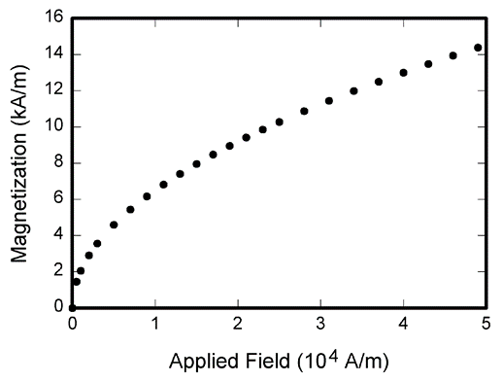
Figure 1. Resultant Graph of the Proposed System

Table 1. Modelling Table
Value 1 | Value 2 | Value 3
2 | 2 | 9
6 | 7 | 4
2 | 9 | 6
All the tables should be presented as shown above.

(1)
All the mathematical equations should be numbered as shown above.
- CONCLUSION
Conclusion part depicts the main points as the constructive finds obtained from the proposed system. Conclusion should not be the same as abstract. Conclusion should be modelled efficiently.
CONFLICTS OF INTEREST
Fill the text from your manuscript in different sections. Fill the text from your manuscript in different sections.
FUNDING STATEMENT
Fill the text from your manuscript in different sections. Fill the text from your manuscript in different sections.
ACKNOWLEDGEMENTS
Fill the text from your manuscript in different sections. Fill the text from your manuscript in different sections. Fill the text from your manuscript in different sections.
REFERENCES
- G. O. Young, “Synthetic structure of industrial plastics (Journal Article)”, Plastics, vol. 3, no. 2, pp. 15–64, 1964. [CrossRef] [Google Scholar] [Publisher Link]
- G. O. Young, Synthetic structure of industrial plastics (Book style with paper title and editor), in Plastics, 2nd ed. vol. 3, J. Peters, Ed. New York: McGraw-Hill, 1964, 15–64. [CrossRef] [Google Scholar] [Publisher Link]
- G. O. Young, “Synthetic structure of industrial plastics (Conference Proceedings),” International conference on ACIDS 2020, Phuket, Thailand, March 23-26, 2020. [CrossRef] [Google Scholar] [Publisher Link]
AUTHORS

First Author and the other authors may include biographies at the end of regular papers. In this section authors can include their studies number of publications they have and any achievements the authors have obtained. All the authors can include their photos as well as biographies, if they wish.

Arrived: xx.xx.xxxx
Accepted: xx.xx.xxxx

